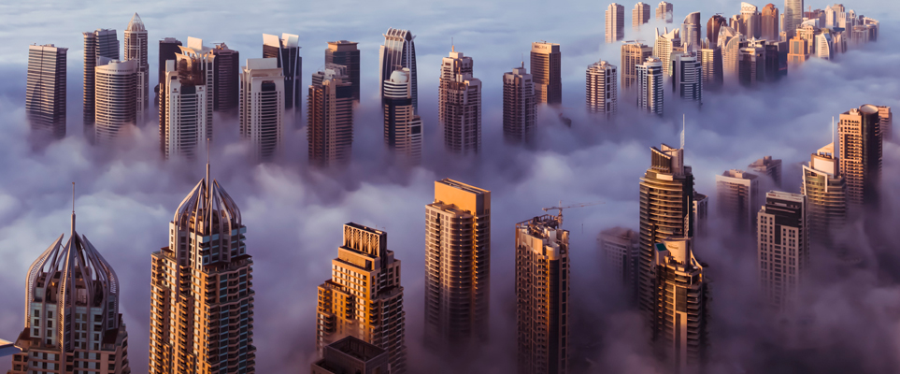

**Something for Everyone- Welcome to Dubai.**

It is quite stressful to travel somewhere without knowing what you want to do, or what you enjoy. If this sounds like you, then Dubai is the place for you. Catering to almost all kinds of experiences from a vibrant culture, luxurious lifestyle, futuristic skyline and more, it has something for everyone.

This is a one-stop guide to experience Dubai for all it offers. The article will separate the trip to different categories, so you can find something you enjoy.

**HERE ARE TOP 10 THINGS TO DO IN DUBAI.**

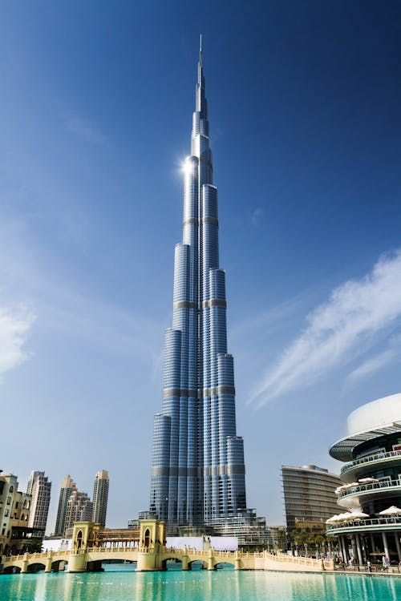If you are a person that enjoys architecture and culture, then in the following places you will get to witness the Old and New Dubai come alive.

1. **BURJ KHALIFA**-

This is the name you’ll hear most associated with Dubai, because it is the world’s tallest building. It is an architectural marvel. And to enjoy it further, make sure to visit the top floors to get the panoramic view of the city skyline.

**Things to see and do**:

* Artworks and installations from various artists.
* Sunset/sunrise view from the observation decks
* Aquarium
* Brunch lounge and dining area

**Ticket cost**: 179- 769 AED (standard to VIP passes)

**Website:** You can book these tickets from the official website: <https://www.burjkhalifa.ae/en/>

1. 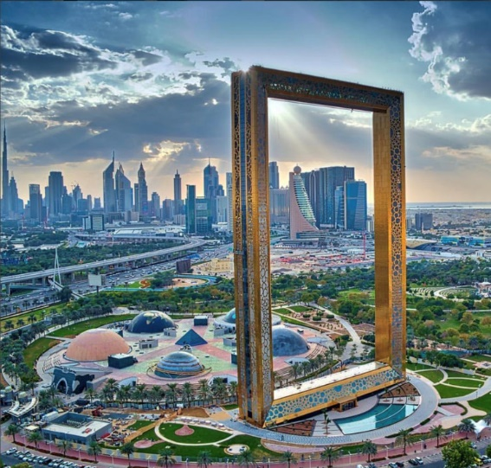**DUBAI FRAME**- it is considered the transformative point of connection between the Old and New Dubai. You will be able to see both the futuristic buildings of the modern city as well as the quiet town it grew out of. It is an interactive exhibit that tells the story of past, present and future Dubai, with an observation deck and museum.

**Things to do:**

* Observation deck with a panoramic view of the city
* Interactive exhibits
* Glass walkway

**Ticket:**  50 AED per adult. 20 AED per child.

You can book the tickets according to date and time and ticket availability on the –

**Government Of Dubai Website** : <https://ticketingsales.dubaiframe.ae/?lang=en>

1. **DUBAI MALL AND DUBAI FOUNTAIN** – It is one of the largest shopping malls in the world, with entertainment, high-end fashion, an aquarium, and more. And the Fountain has a show, captivating its audience with a water and light show against the backdrop of the Burj Khalifa.

**Things to do:**

* Fountain shows from: Every 30 mins. From 6 pm -11pm daily.
* Shopping
* Shows and activities inside the mall

**Price:**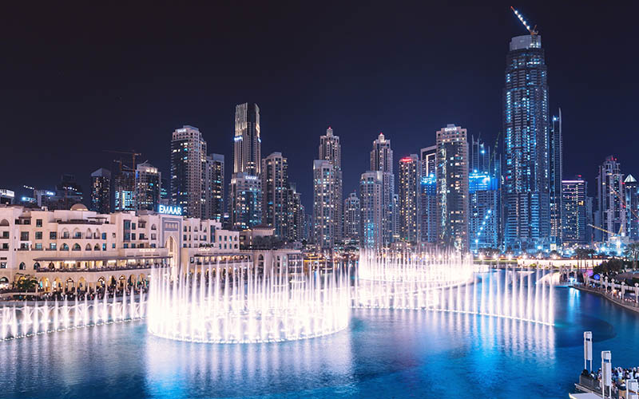 Open to the public without a fee. To access the shows within the mall, there will be a fee.

1. **DUBAI MUSEUM AND AL FAHIDI FORT**- Take a stroll back in time to the city’s oldest existing buildings. To experience the rich culture, to remember how it started, and honour where they are now.

**Tickets:** ( 3 AED per adult, 1AED per child)

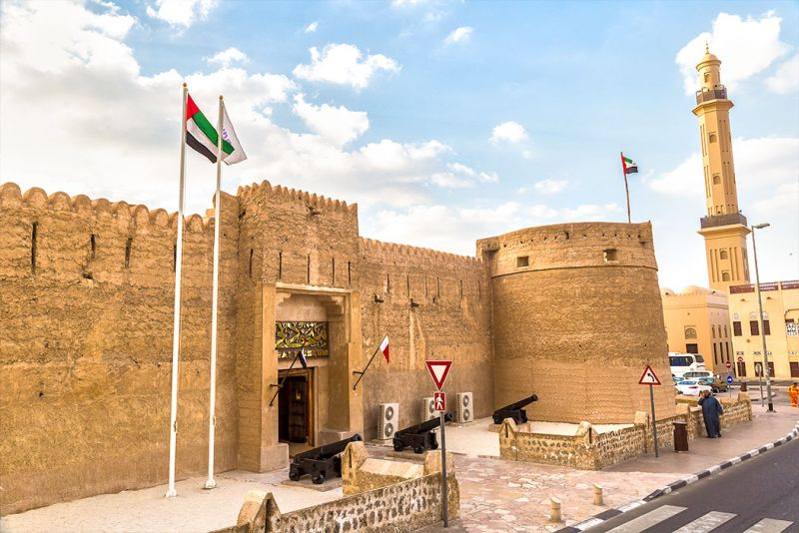

If you are more of a person who is here for a staycation or here to relax luxuriously, avoiding the hustle and bustle, then Dubai has these options for you.

1. **The Palm Jumeirah**- It is the famous palm shaped, man-made islands that we often see in movies. It hosts a string of luxurious resorts, pristine blue beaches and high-end dining. You can indulge in your most luxurious dreams here. The infamous Atlantis hotel is located in this island.

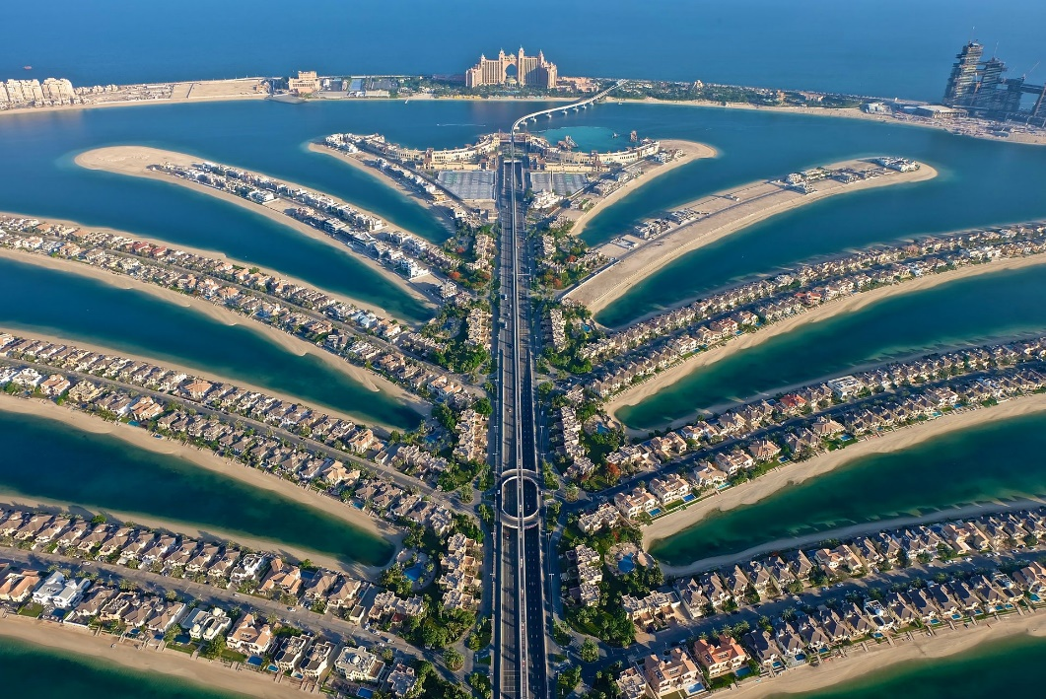

**Things to do:**

* Beach clubs
* Night clubs
* DJ parties
* Spas
* Infinity pools and more.

**Price:** Depends on the particular establishment you choose to go to.

1. 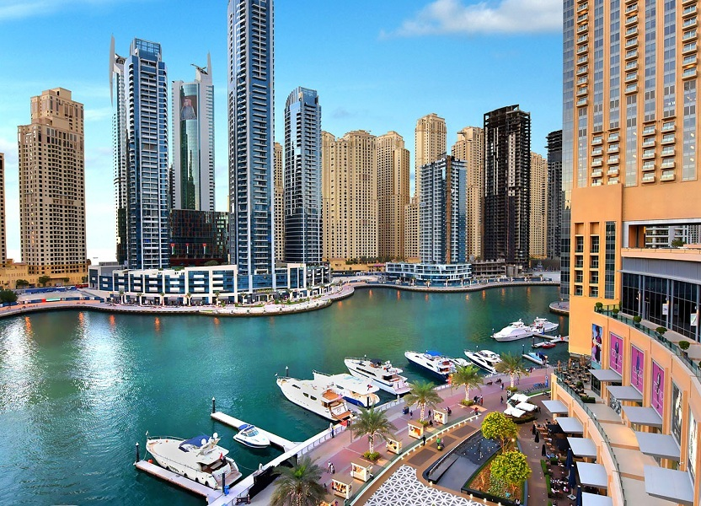**DUBAI MARINA**- This is an artificial canal city along the Persian-gulf shoreline. The best time to visit is between the months of November and April as the temperature will be comfortable for excursions during the day.

**Things to do:**

* Book private luxury yachts
* Waterfront cafes with a view.
* Dhow cruise or dine at restaurants to have dinner with a magnificent view.

**Tickets :** 130AED – 1900 AED – for boats -depending on time spent and exclusivity.

1. 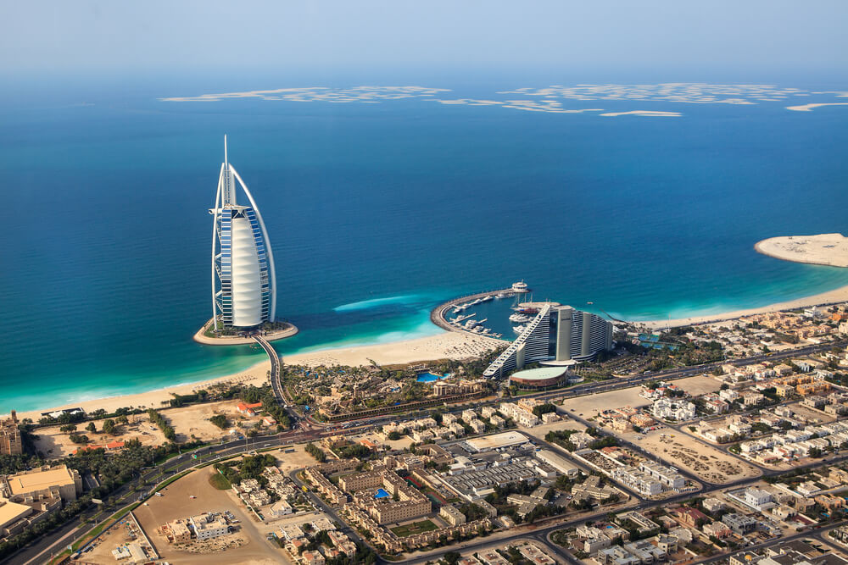**JUMEIRAH BEACH AND BURJ AL ARAB**- The sun-kissed sands of the Jumeirah beach also host the Burj Al Arab luxury hotel. It is a sail-shaped luxury hotel, giving you access to all the quality experiences.

**Things to do:**

* Activities on the beach: Kite flying, Speedboat tour, Jet-ski ride, yachts and more.
* Fine dining
* Spa.
* Clubs

**Price:** Beach has free entry. There will be parking charges for vehicles. Access to activities, private clubs and such will come with a fee upwards from 150 AED.

On the other hand, if you are an adrenaline junkie, and you want this trip to be an escape from the monotony of life, then Dubai has something for you as well. Please ensure to book ahead because these are highly popular events.

1. **DUNE BASHING IN THE DESERT**- Experience an off-road adrenaline pumping ride across the dunes of the Dubai desert. Even kids are allowed to take part, but do measure the risk on your own before signing up. The ride lasts maximum of 45 mins across the dunes. They will perform stunts and such, and stop at any dune for you to take pictures. Make sure to bring sunglasses to protect your eyes, and wear flipflops as the sand gets in everything.

**Tickets :** 4-10 yrs old – 100AED. 11 yrs and above- 130AED

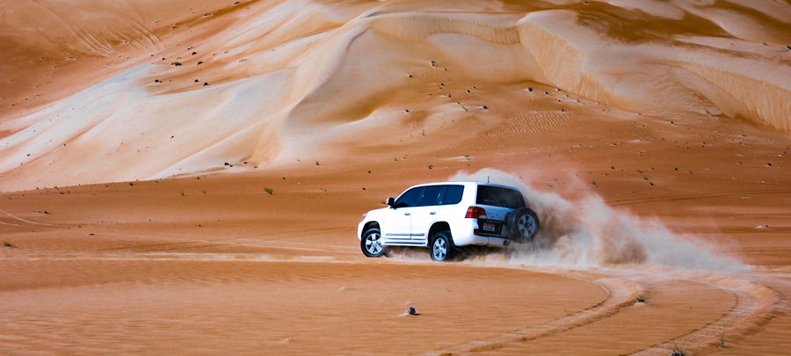

1. **SKY DIVING** – Soar above the breathtaking Dubai skyline as you safely freefall. This is the most sought-out event because of its recent rise in popularity. Hence, early booking is mandatory.

**Tickets:** For tandem skydiving (with an experienced instructor)- the prices go up from 1,899 AED. You can get photos, videos and reels of yourself for additional changes that start form 150 AED.

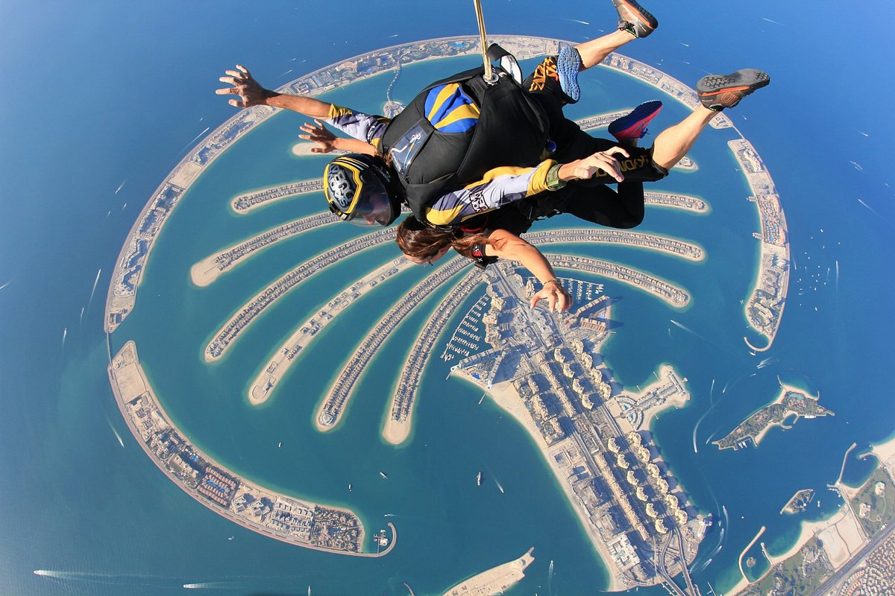**Website:** For more information on services and pricing: <https://www.skydivedubai.ae/en/experienced-skydiving/prices>

1. **SANDBOARDING-** It is similar to snowboarding except you ride the slopes of the desert dunes. Dubai desert has the views and slopes for you to get the rush. It is quite a popular tourist attraction that all ages can enjoy.

**Also includes:**

* Sunset Rides
* Camel Farm Visit
* Desert Safari
* Quad bike rides.

**Ticket**: Start from 95 AED- 187 AED.

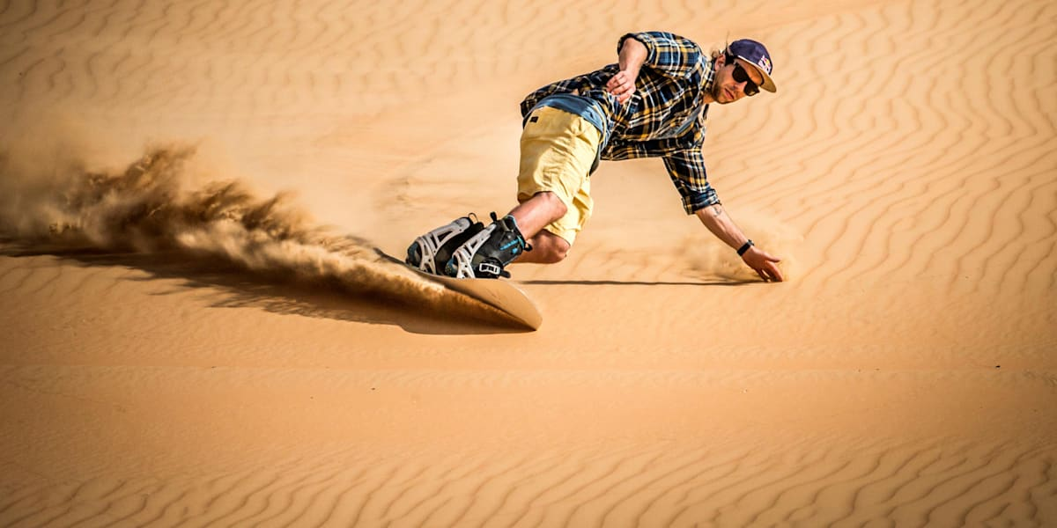

Also including some unique spots that Dubai hosts-

1. **DUBAI MIRACLE GARDEN**-

This flowered paradise, is the epitome of beauty. Opens during the winter months with over 150 million flowers in full bloom.

**What to see:**

* Umbrella Tunnel
* Sunflower Field
* Floral Clock
* Smurfs Village
* Lake Park
* Hill Top

**Tickets:** 3- 12 yr olds- 80 AED (with ID).

Above 12 yrs - 90 AED. Under 3 – Free (with ID)

**Website**: <https://www.dubaimiraclegarden.com/> - for further information

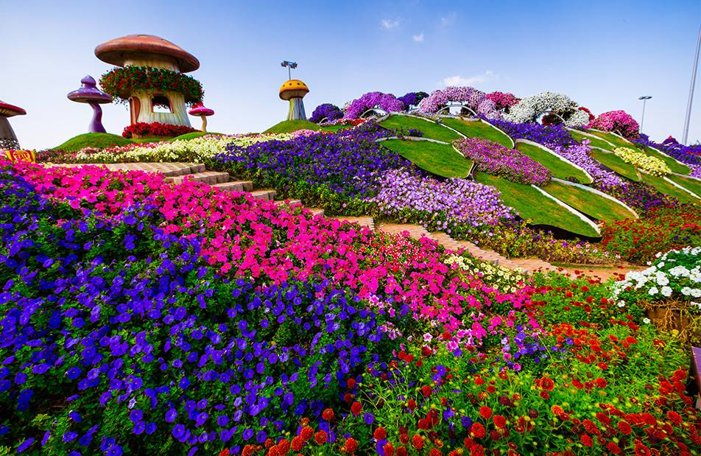

1. **GLOBAL VILLAGE**

It is a vibrant cultural and entertainment destination that features pavilions representing different countries and regions around the world. Over 75 pavilions of different countries present.

**Things to do:**

* Explore pavilions of different countries
* Live shows- performances of music and dance from different countries
* Shopping for handicrafts, souvenirs and more
* Dining- international cuisines
* Funfair rides – attractions for all ages.
* Cultural exhibitions – showcase the heritage and traditions of different cultures
* Firework shows on select nights

**Tickets:** Entry fee- 15- 20 AED per person. Open daily from late afternoon until late evening (October to April).

**Website:** <https://www.globalvillage.ae/en/> -for more information.

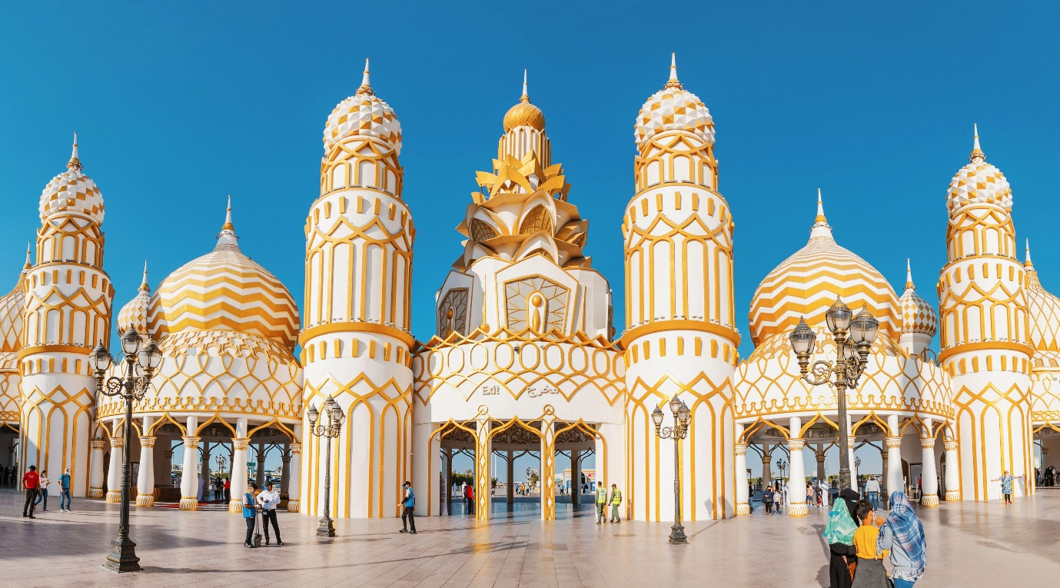

1. **DUBAI OPERA**

It is a prestigious cultural venue known for its spectacular architecture and diverse program of performing arts.

**Things to do:**

* World class opera, ballet, classical music, theatre productions and contemporary performances
* Dining -pre show.
* Rooftop view of the Dubai fountain and the Burj Khalifa
* Art exhibitions and cultural displays

**Tickets:** Range from 150 AED to 1,000 AED or more for premium performances.

**Website:** <https://www.dubaiopera.com/en-US/home> - for more information.

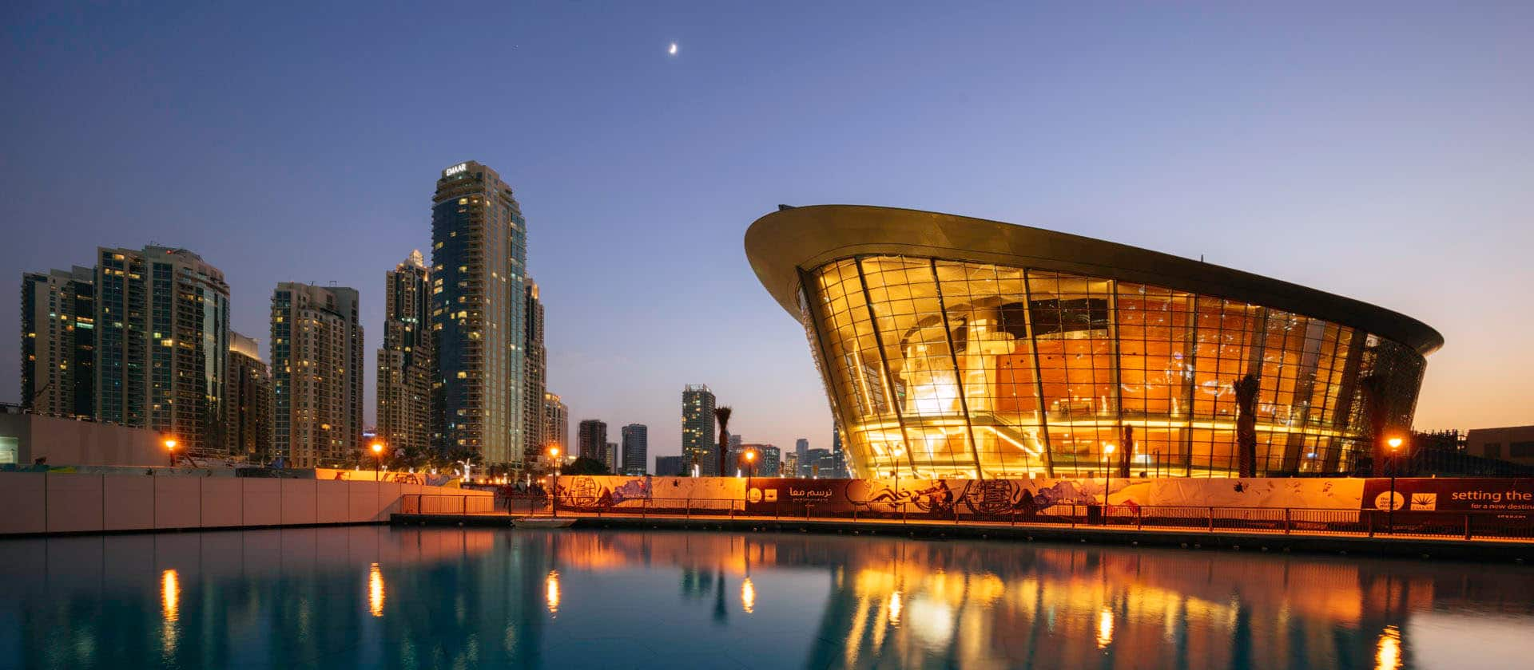

1. **DUBAI AUTODROME**

They provide an exhilarating venue for motorsport enthusiasts – for competitive racing, leisurely karting, or experiencing high- performance cars on world class circuit.

**Things to do:**

* Karting – even for beginners
* Driving experience with high-performance cars
* Race meetings and championships

**Tickets:** Karting – start from 120 AED per person for a timed session. Track day prices vary based on event and vehicle category, also require pre-registration.



1. **DUBAI INTERNATIONAL MOTOR SHOW**:

It is a biennial automotive exhibition showcasing the latest vehicles, concepts and automotive technologies.

**Things to do:**

* Explore exhibits of latest models from global automotive brands
* Attend launches- new vehicle unveiling
* Interactive displays
* Meet celebrities and experts in the automotive industry
* 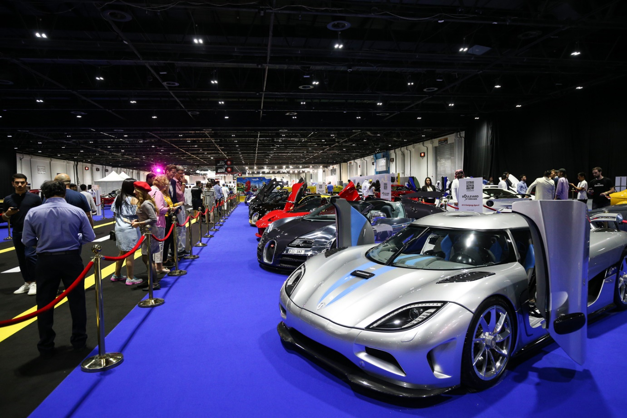Test drives of latest models

**Tickets:** Range from 50 AED to 200 AED per person- discount for early bird booking and group tickets. Prices vary depending on day and type of ticket also.

1. **DUBAI GOLD SOUK**

This place offers a unique cultural and shopping experience, making it a must-see destination for visitors interested in jewellery, craftsmanship, and Middle Eastern market culture.

**Things to do:**

* Shop for Gold Jewellery
* Make custom designed jewellery
* Explore surrounding- nearby Spice Souk and Dubai creek for more traditional trading heritage.

**Prices:** Gold price will be based on current market rates and craftsmanship, can negotiate and bargain for good deals.

**PLEASE NOTE:** You are only allowed to carry a certain amount of gold back to India. The current limit is – 20gms of gold for a man, and 40 gms of gold for a woman. If it exceeds the duty-free limit, you will have to pay customs charges.

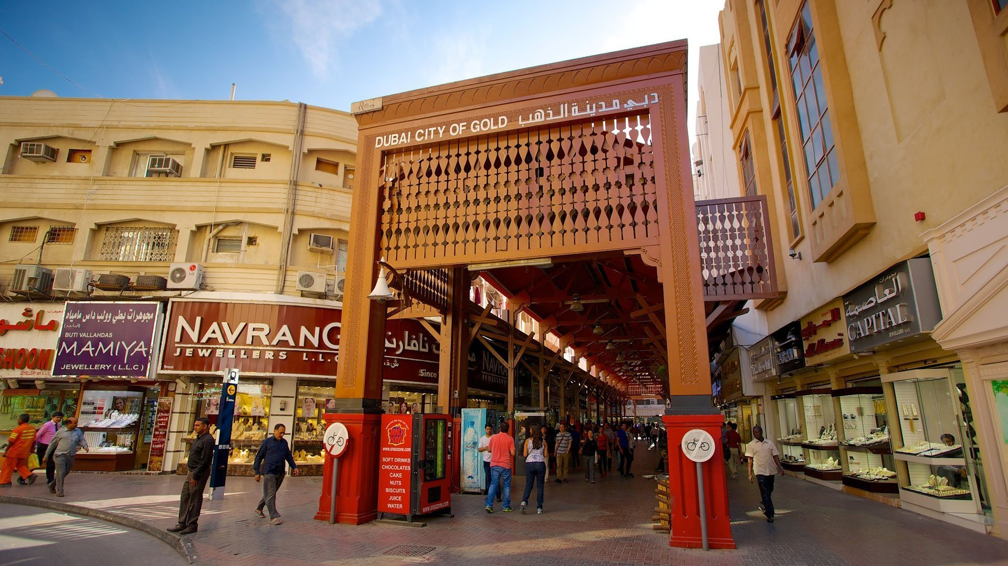

1. **LEGOLAND DUBAI**

It is a family-friendly theme park offering attractions and activities centred around the iconic Lego bricks.

**Things to do:**

* Rides and attractions
* Miniland- with replicas of famous landmarks and cityscapes from the Middle East and beyond.
* Lego building throughout the park
* Shows and entertainment- live and 4D
* Dining and shopping

**Tickets:**  Vary according to pass type, age and package. For single day passes – range from 275AED to 345 AED per person.

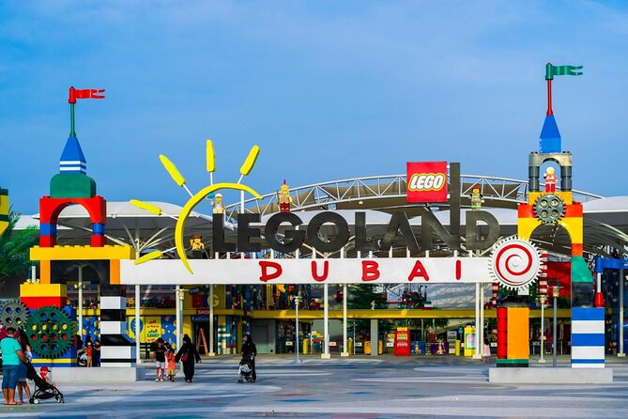

1. **OLIOLI DUBAI**

It is an interactive children’s museum designed to inspire learning and creativity through exploration with hands-on exhibits and activities.

**Things to do:**

* Themed galleries based on Toshi’s Net, Future Park, Water gallery etc.
* Hands-on activities involving science, technologu, art, engineering and maths.
* Sensory play
* Workshops and classes
* Can host private birthday parties.

**Tickets:**  Based on age and package. Start from 126 AED per child (2- 16 yrs old) and 42 AED per adult- discounts for online booking and memberships. 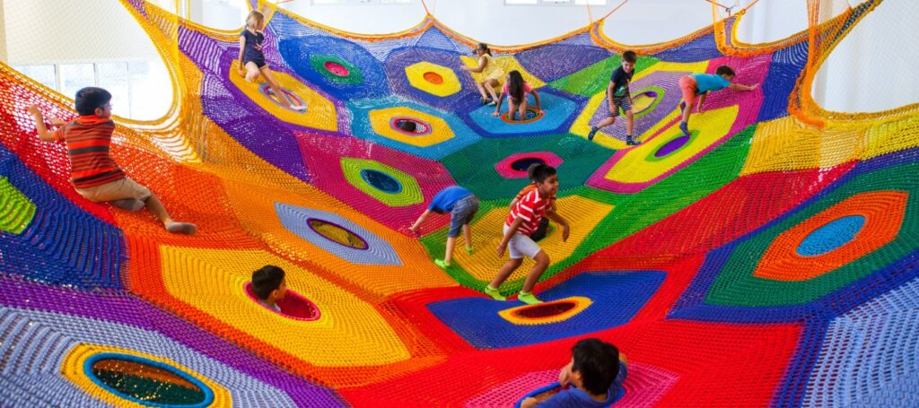

Now, to note a few things before you travel to Dubai-

* Indians will need a VISA to enter Dubai.
* Transportation in Dubai- metros, taxis and other services are available to travel between these places. It isn’t necessary for you to rely on hired cabs, they have a good public transportation system.
* Tickets and Reservations- Some places require early booking, especially adventure sports and popular attractions like the Burj Khalifa.
* Dress Code- Please make sure to dress modestly, especially while visiting religious sites or public areas. As a traveller it is our responsibility to respect the culture of the country. Please look up dress codes especially when visiting religious places. . Dress with the heat in mind, and carry sunscreen to protect your skin.
* Timing- Do try to visit outdoor attractions during cooler parts of the day, especially in the summer. Or visit during the autumn- spring months between November to April.

Dubai is a land of unforgettable blend of modernity, luxury and cultural richness. As a novice traveller, it can open to you a world of experiences. So, embrace the adventure and enjoy all the beauty that Dubai has to offer.